Digital Library

Documentation

By Stanislava Andonova [srandonova18@codingburgas.bg](mailto:srandonova18@codingburgas.bg)

Jacqueline Yordanova [zoyordanova18@codingburgas.bg](mailto:zoyordanova18@codingburgas.bg)

Dimitar Georgiev [dmgeorgiev18@codingburgas.bg](mailto:dmgeorgiev18@codingburgas.bg)

Petar Petkov [PGPetkov18@codingburgas.bg](mailto:PGPetkov18@codingburgas.bg)

Mentor: Petar Georgiev

VSCPI

Computer programming



Table of Contents

Purpose of the project 2

Diagram 2

Most important functions 3

Digital Library

# Purpose of the project

We live in a time when it is almost impossible to exist without technology. We can find it in everything – medicine, education, houses, cars etc. It is usually used to make our everyday life a little bit easier. Many companies and stores use different types of programs to collect, register and organize data. We didn’t want to make a program for a shop because it seemed very basic and not that original so we decided to do something different.

In today’s world if somebody wants to read a book or look for information regarding a certain topic, they will probably use the Internet because there you can find almost everything. This results in one industry slowly starting to disappear. Not a lot of people visit libraries nowadays because they seem ‘old school’ in a way, but we decided to help change that. Our program’s purpose is to be used for managing the visitors of a library. There you can register new visitors, edit their profiles, delete them or find many different options for reports, based on the data entered.

# Diagram

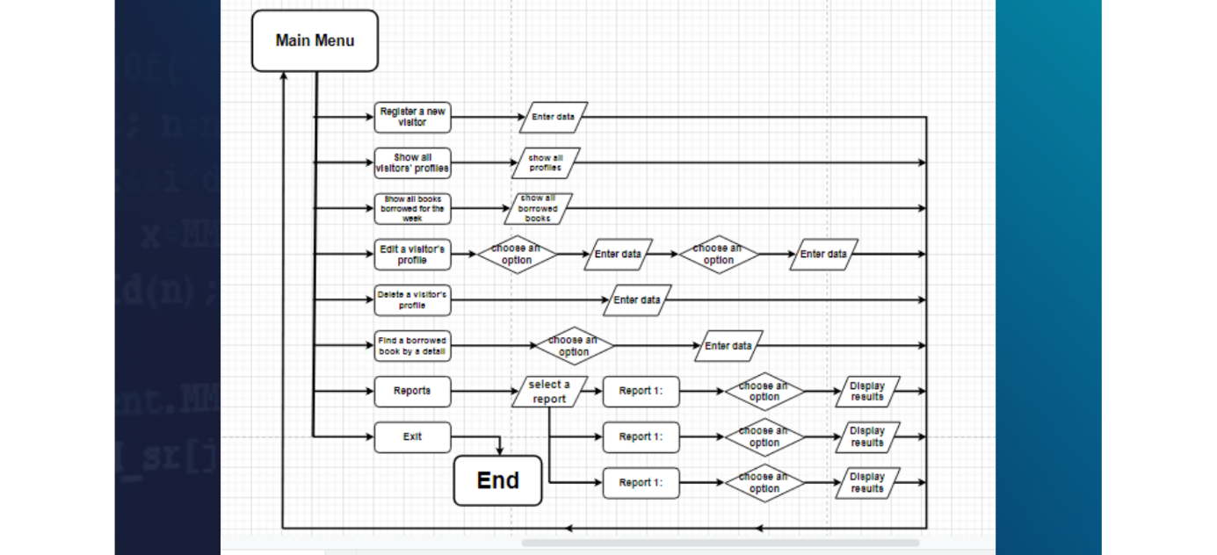

|  |  |  |  |
| --- | --- | --- | --- |
| Function name | What is it used for | Arguments | Return type |
| findVisitorById | To find a particular visitor by their ID | VISITOR* visitors, int& visitorCount, int id | Int because the ID is a whole number, used to identify a user |
| newVisitor | To register a new visitor | VISITOR* visitors, int& visitorCount, VISITOR newVisitor, int& maxId | void (no return type) because it is not needed |
| deleteVisitor | To “delete” a particular visitor | VISITOR* visitors, int& visitorCount, int id | void (no return type) because it is not needed |
| readInt | To check if the value entered is an integer | String message | Int because it returns the value entered after it is acceptable |
| showVisitorsMenu | Shows all registered visitors | VISITOR* visitors, int& visitorCount, int& maxId | void (no return type) because it is not needed |
| editVisitorMenu | Shows the options for editing a visitor’s profile’s details | VISITOR* visitors, int& visitorCount | void (no return type) because it is not needed |
| editBooksDetailsMenu | To edit a book’s details | VISITOR* visitors, int& visitorCount | void (no return type) because it is not needed |
| editVisitorDetailsMenu | To edit a visitor’s details | VISITOR* visitors, int& visitorCount | void (no return type) because it is not needed |
| chooseDayOfTheWeek | To choose a day of the week from a list | none | WEEK_DAYS because it returns an enum class element used to identify the days of the week |
| weekDayToString | To convert enum elements to strings | WEEK_DAYS weekDay | String because it prints the name of the day |
| showAllBorrowedBooksBy  ADetailMenu | To show all books that have passed a specific criteria | VISITOR* visitors, int& visitorCount | void (no return type) because it is not needed |
| showReportsMenu | To show all the report options and call the function chosen | VISITOR* visitors, int& visitorCount, int& maxId | void (no return type) because it is not needed |
| showMainMenu | To display the main menu | VISITOR* visitors, int& visitorCount, int& maxId | Bool because unless exit is chosen the menu should keep showing up (returning true), if exit is chosen it returns false and the program stops |

# Most important functions

**VISITOR* visitors** = pointer to the array of type VISITOR

**int& visitorCount** = reference to counter for all visitors

**int id** = variable for user’s input for id

**VISITOR newVisitor** = new visitor to be added to the main array

**int& maxId** = max Id in the visitors array

**string message** = message depending on the function it is used in

**WEEK_DAYS weekDay** = enum variable for choosing a day of the week

All void functions make some kind of edits or call other functions. That’s why they don’t return any values.